https://www.jdoodle.com/embed/v0/5PRK
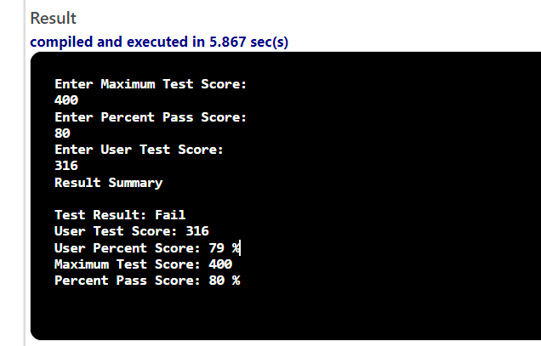
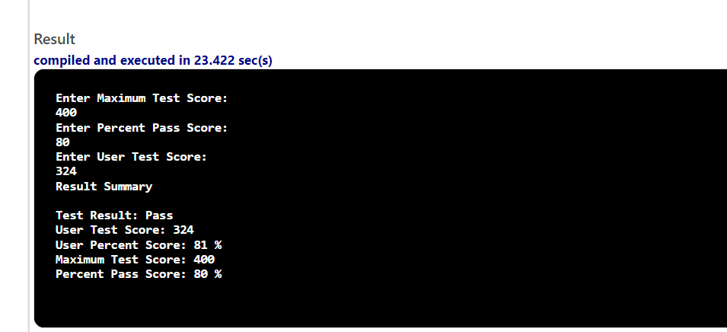

#include <iostream>

using namespace std;

int main() {
// declare variables
double maxScore, pctPassScore, userScore, pctUserScore;
//write code to input maxScore, pctPassScore, userScore
//determine pctUserScore
cout<<"Enter Maximum Test Score: "<<endl;
cin>>maxScore;
cout<<"Enter Percent Pass Score: "<<endl;
cin>>pctPassScore;
cout<<"Enter User Test Score: "<<endl;
cin>>userScore;
pctUserScore = (userScore / maxScore) * 100.0;
cout << "Result Summary" << endl << endl;
if (pctUserScore >= pctPassScore)
{
cout << "Test Result: Pass" << endl;

}

else {

cout << "Test Result: Fail" << endl;

}

cout << "User Test Score: " << userScore << endl;
cout << "User Percent Score: " << pctUserScore << " %" << endl;
cout<<"Maximum Test Score: "<<maxScore<<endl;
cout<<"Percent Pass Score: "<<pctPassScore<<" %"<<endl;
return 0;
}

